**Praktik Jaringan Komputer Enterprise**

**MODUL 7**



**Disusun oleh :**

Cintia Dwi Christinawati

V3921005

**Dosen :**

Yusuf Fadila Rachman, S.Kom., M.Kom

**PS D-III TEKNIK INFORMATIKA**

**SEKOLAH VOKASI**

**UNIVERSITAS SEBELAS MARET**

**2022**

**6.6.7 Packet Tracer – Configure PAT**

**Part 1: Configure Dynamic NAT with Overload**

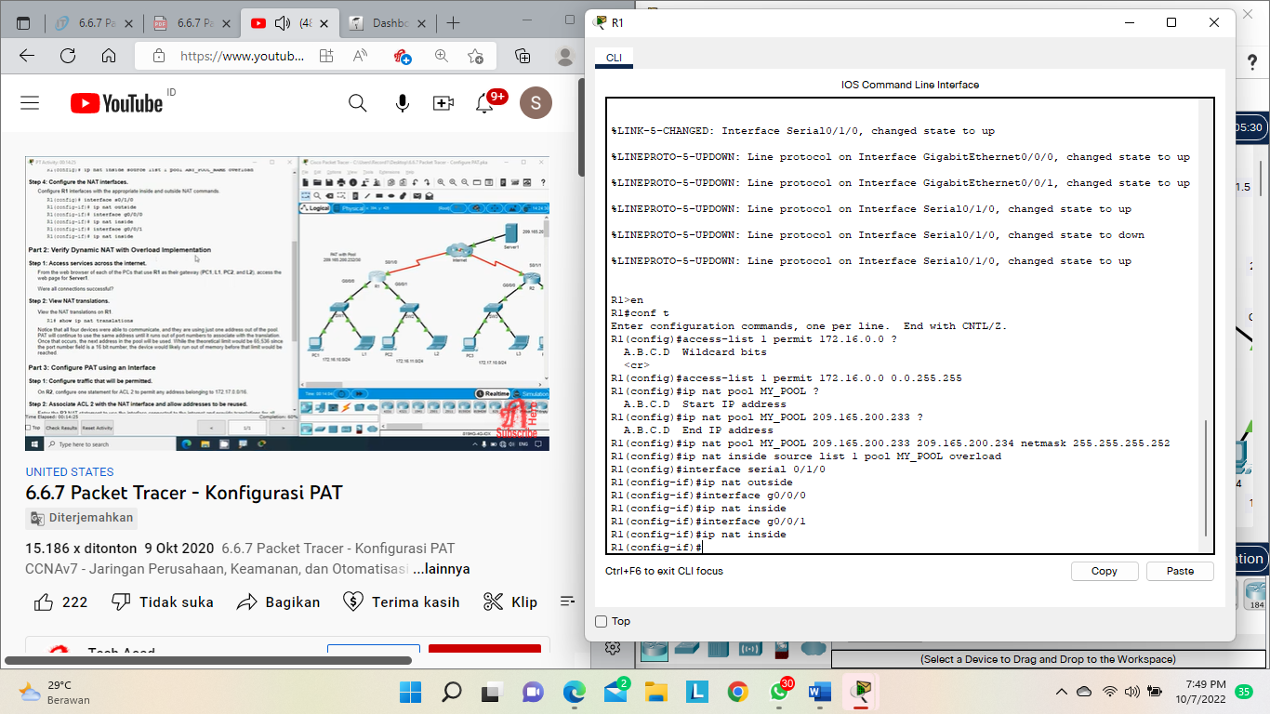

**Part 2: Verify Dynamic NAT with Overload Implementation**

Step 1: Access services across the internet.

From the web browser of each of the PCs that use R1 as their gateway (PC1, L1, PC2, and L2), access the web page for Server1.

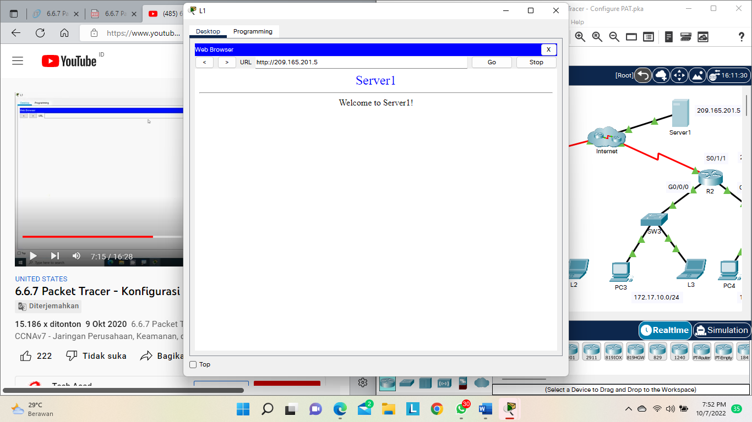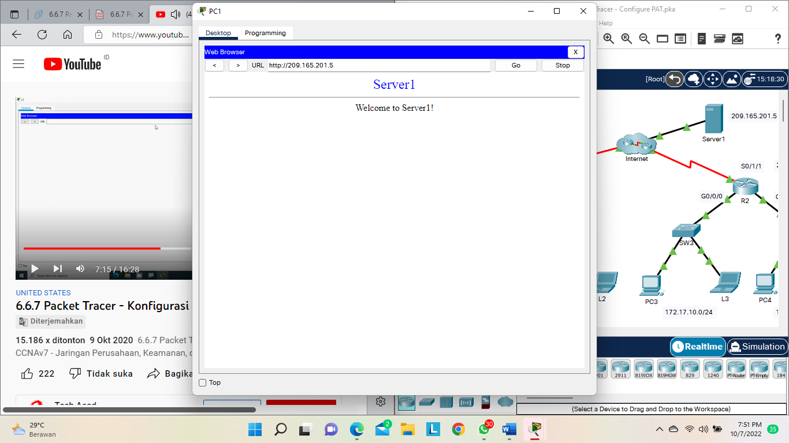

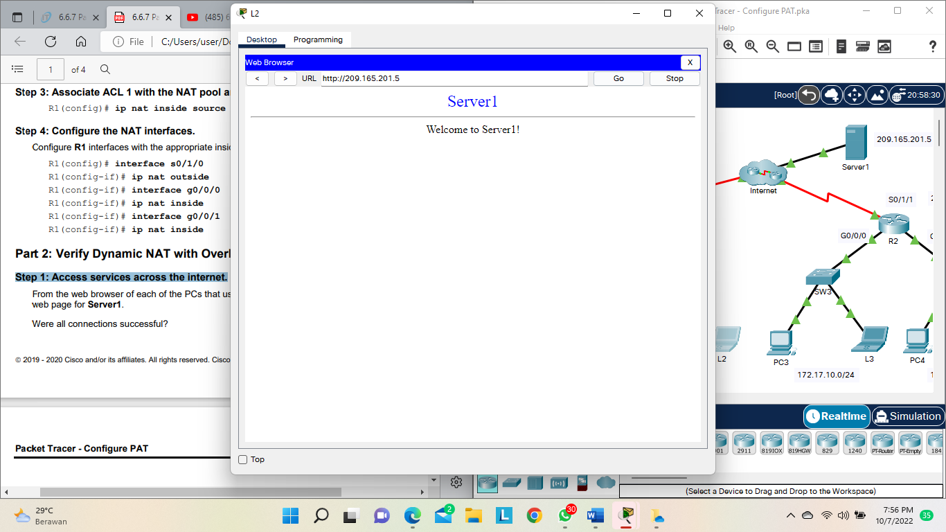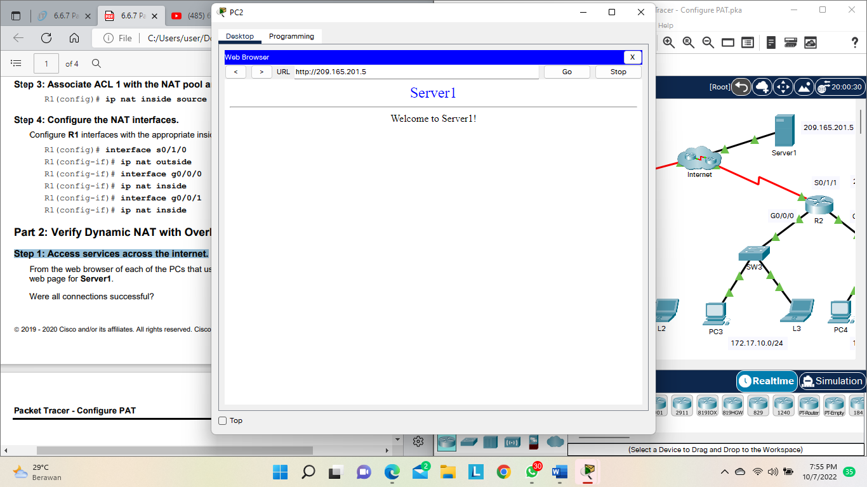

Step 2: View NAT translations.

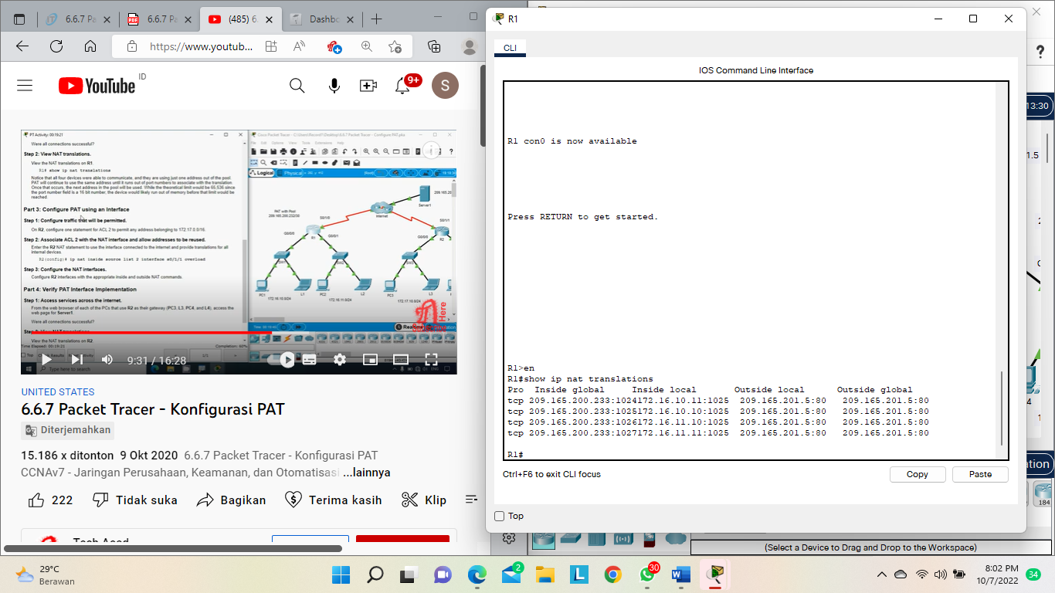

**Part 3: Configure PAT using an Interface**

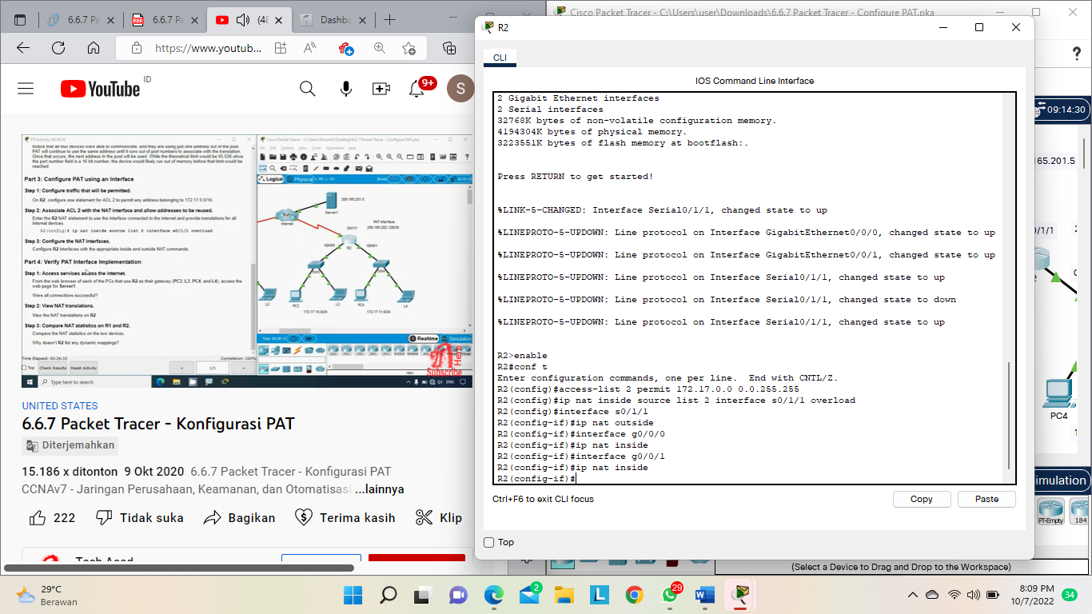

**Part 4: Verify PAT Interface Implementation**

Step 1: Access services across the internet.

From the web browser of each of the PCs that use R2 as their gateway (PC3, L3, PC4, and L4), access the web page for Server1.

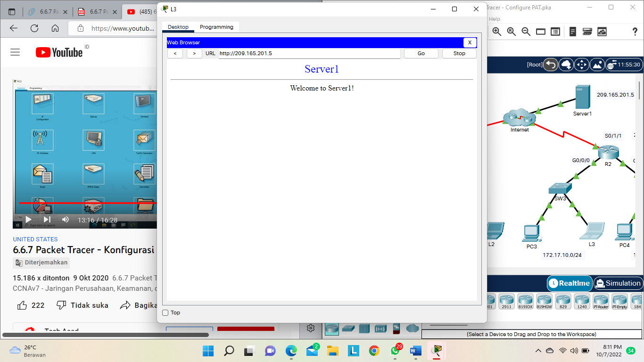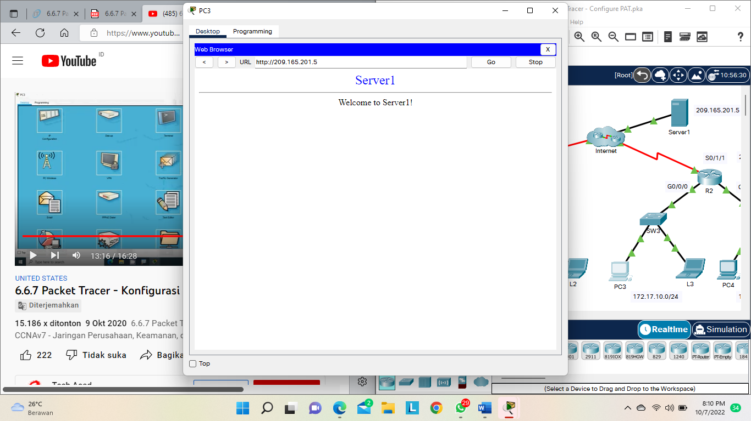

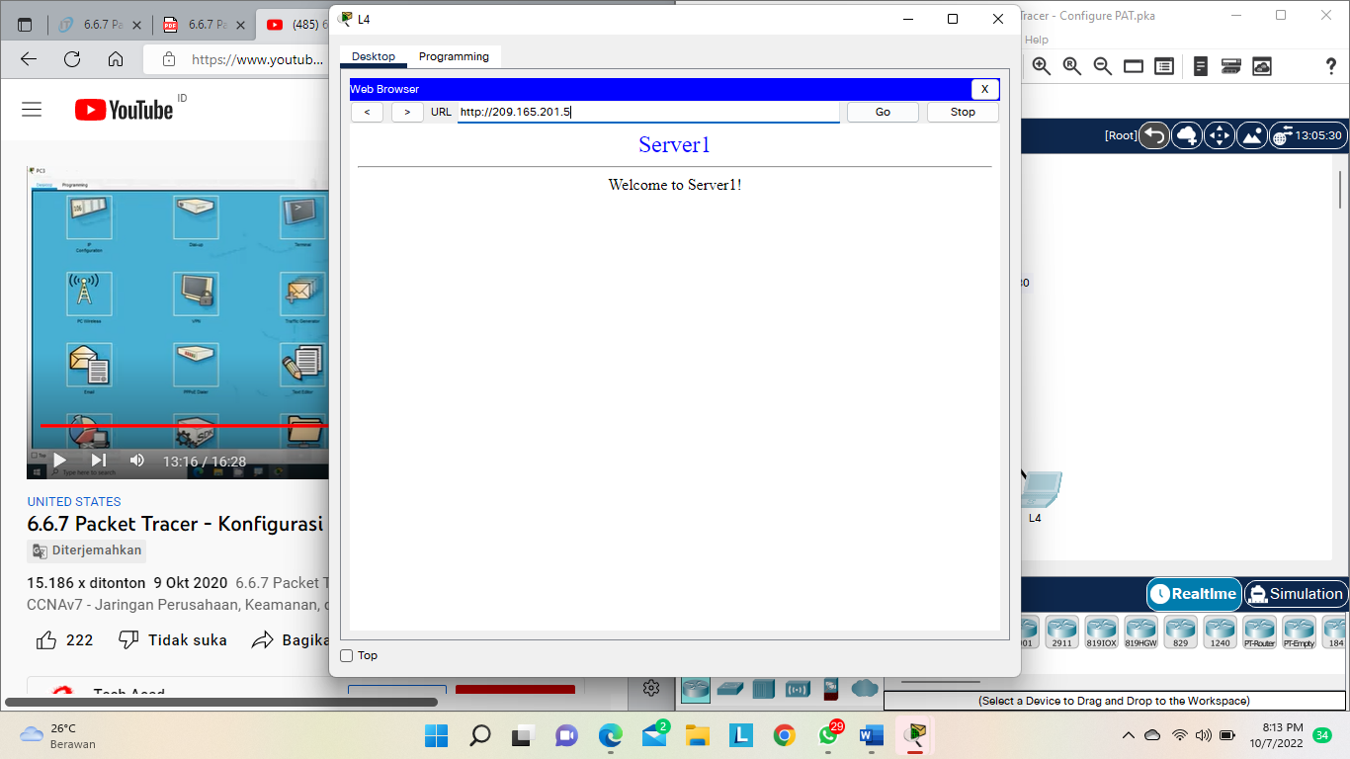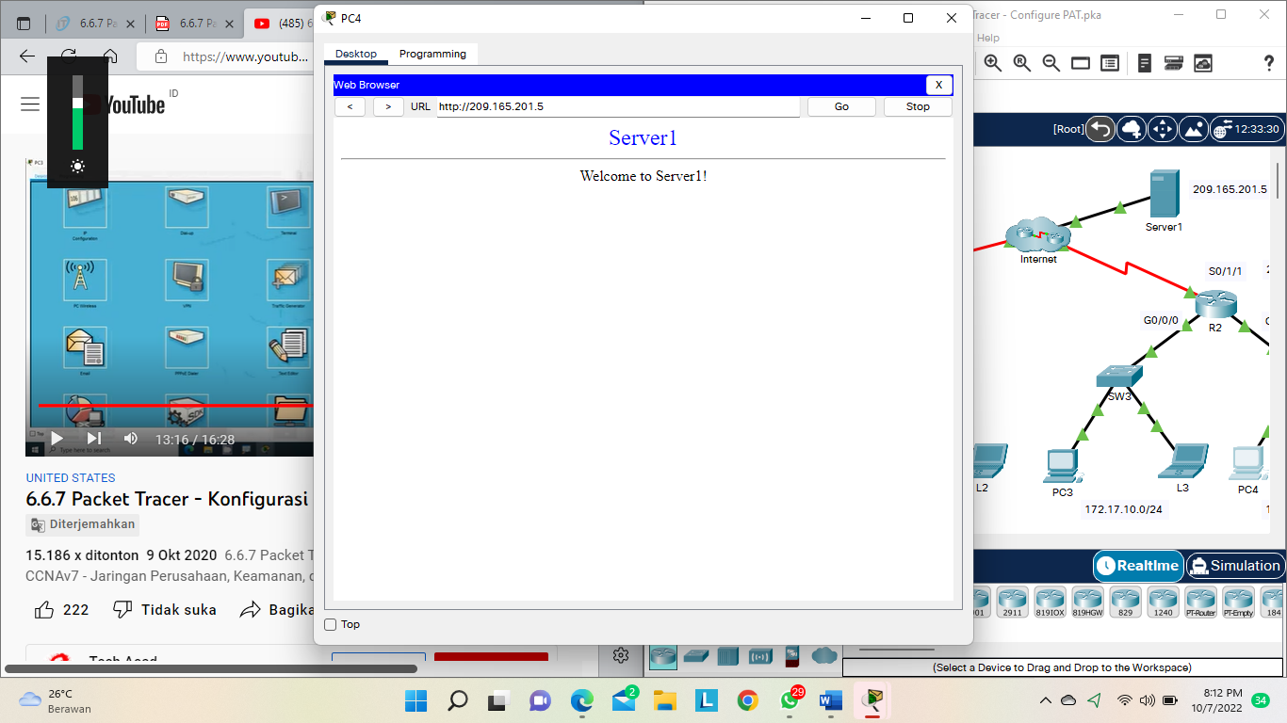

Step 2: View NAT translations.

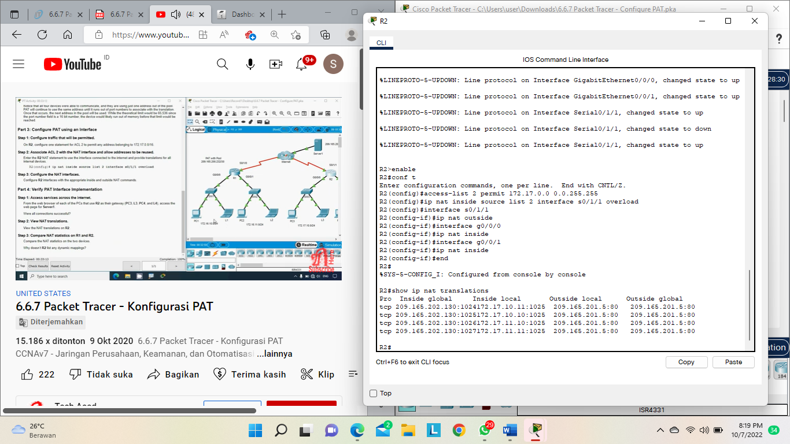

Step 3: Compare NAT statistics on R1 and R2.

Hasil Simulasi :

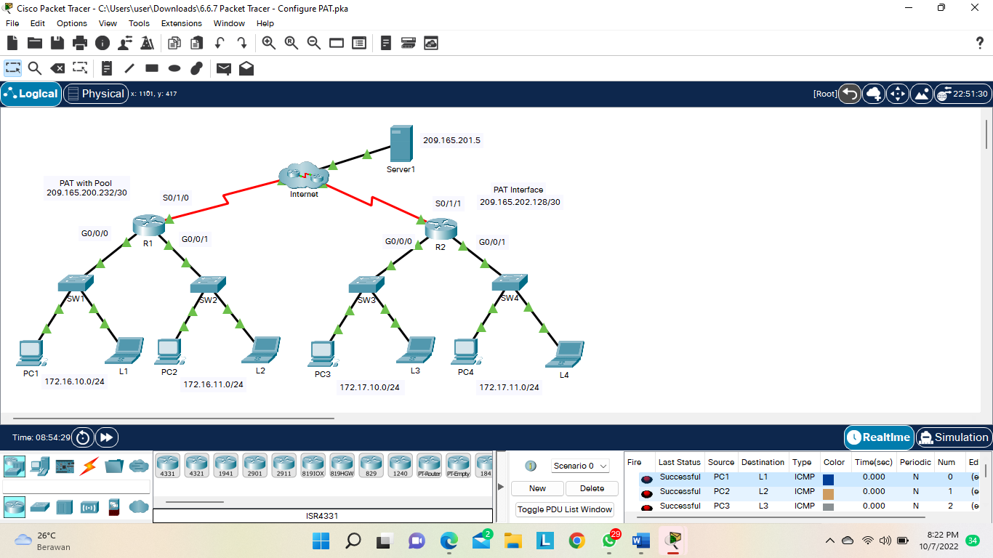

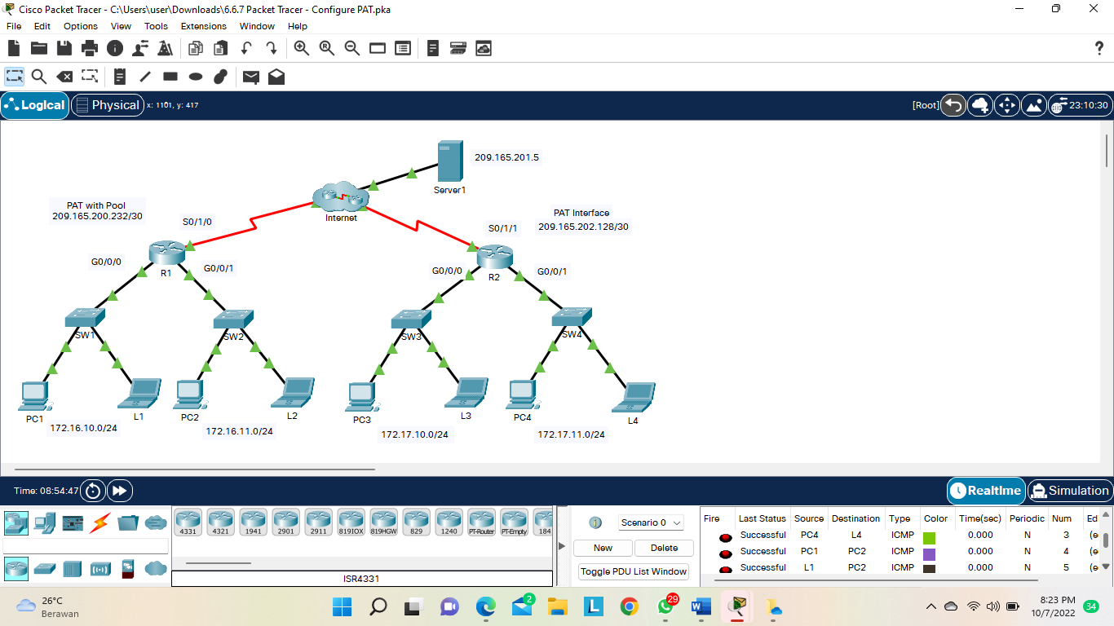

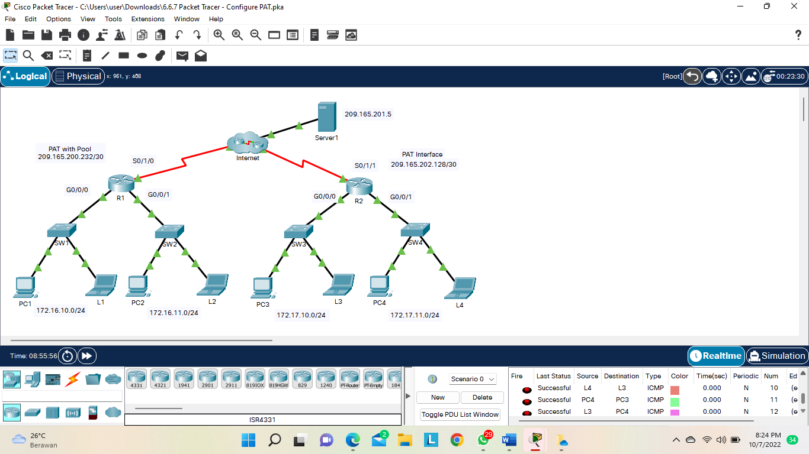

**6.8.1 Packet Tracer – Configure NAT for IPv4**

In this activity you will only configure router R2. Open configuration window

• Use a named ACL to permit the addresses from LAN1, LAN2, and LAN3 to be translated. Specify the LANs in this order. Use the name R2NAT. The name you use must match this name exactly

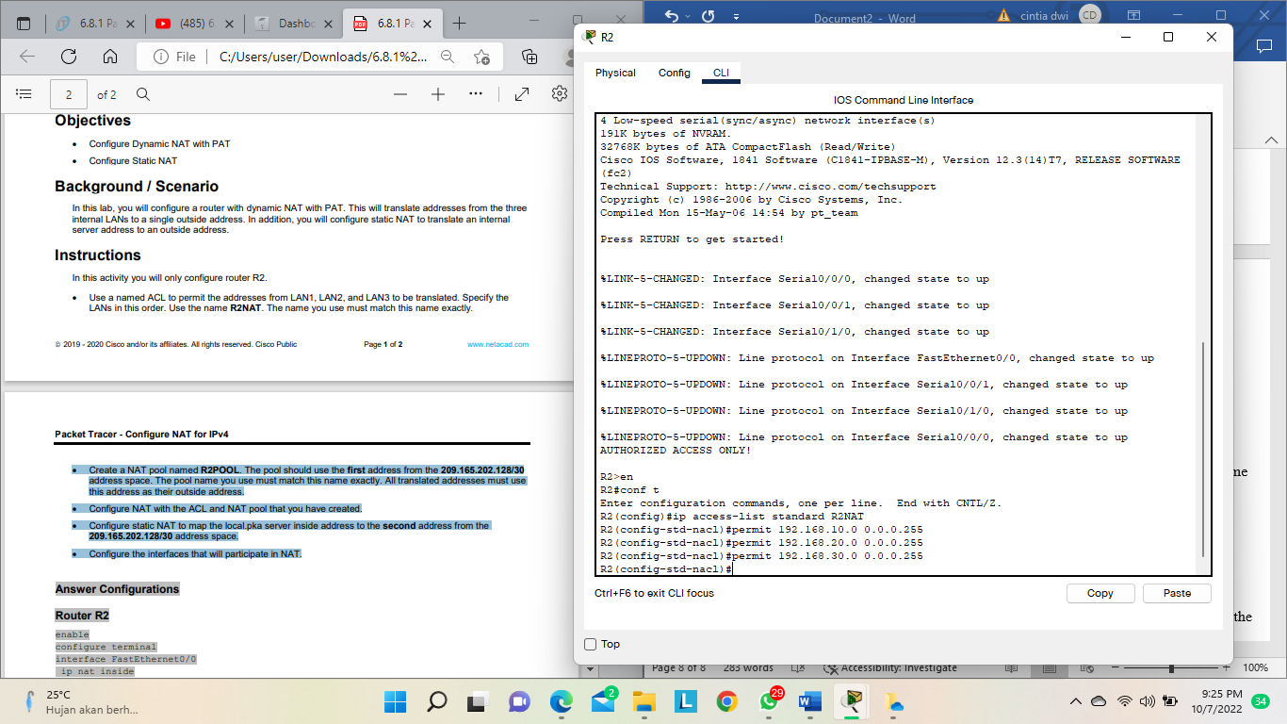

• Create a NAT pool named R2POOL. The pool should use the first address from the 209.165.202.128/30 address space. The pool name you use must match this name exactly. All translated addresses must use this address as their outside address.

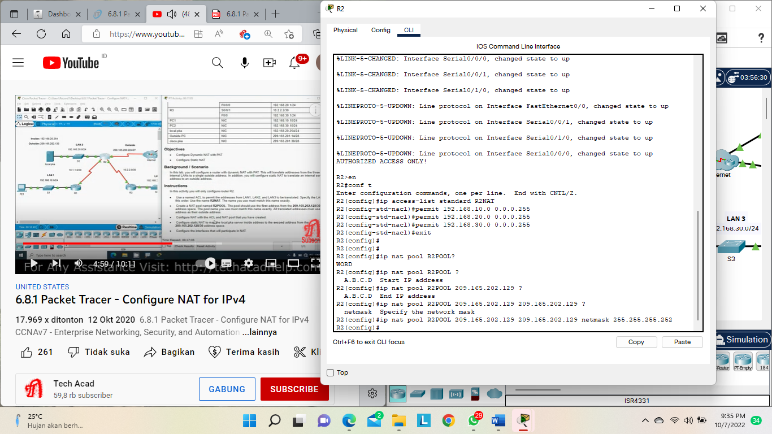

• Configure NAT with the ACL and NAT pool that you have created.

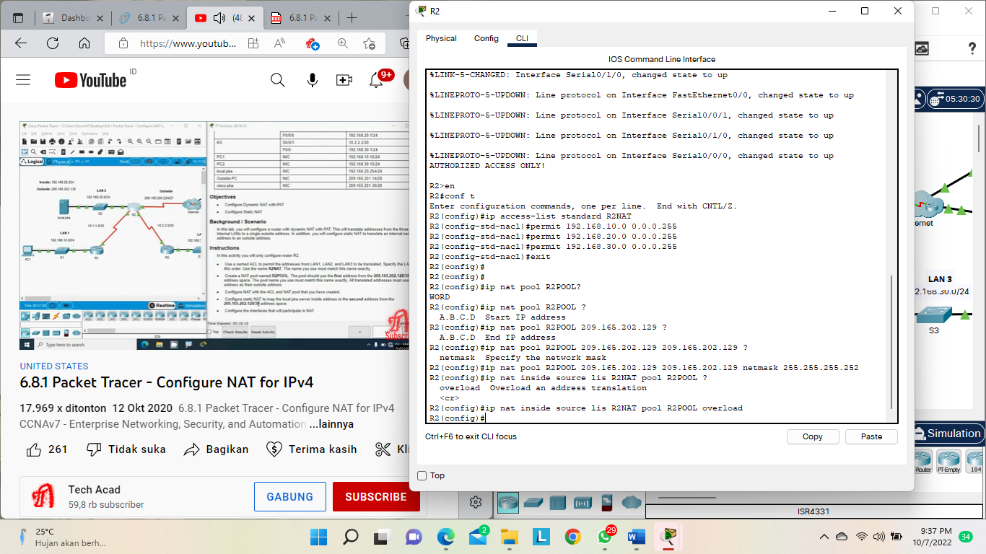

• Configure static NAT to map the local.pka server inside address to the second address from the 209.165.202.128/30 address space.

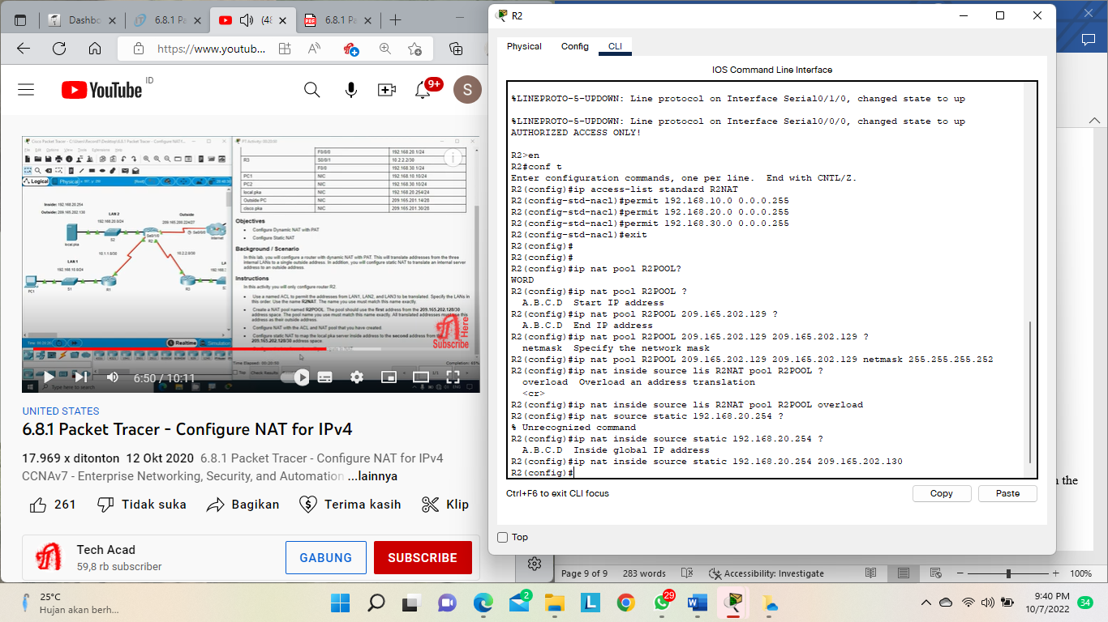

• Configure the interfaces that will participate in NAT.

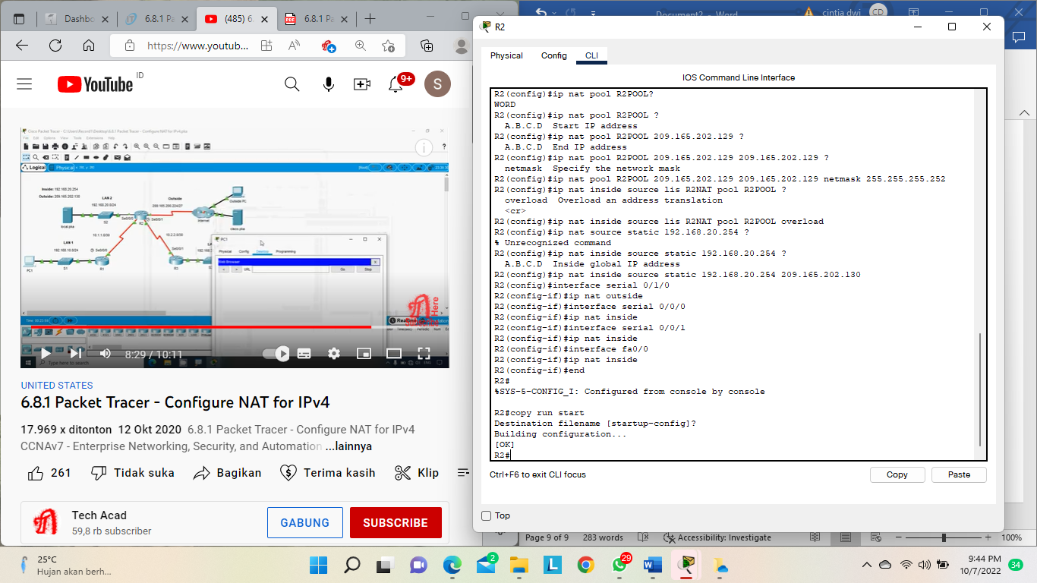

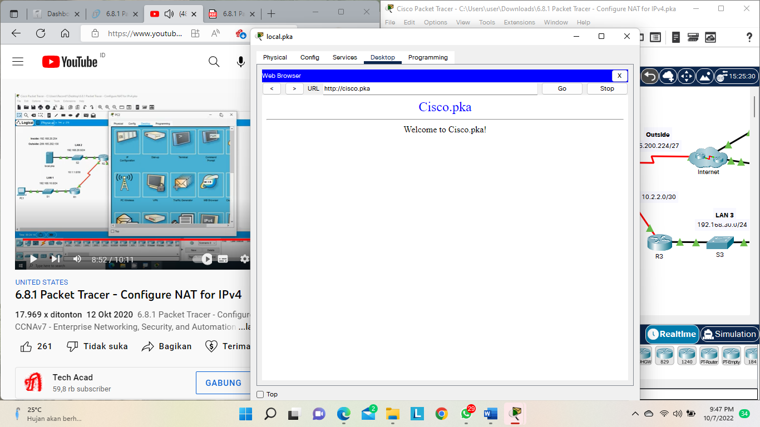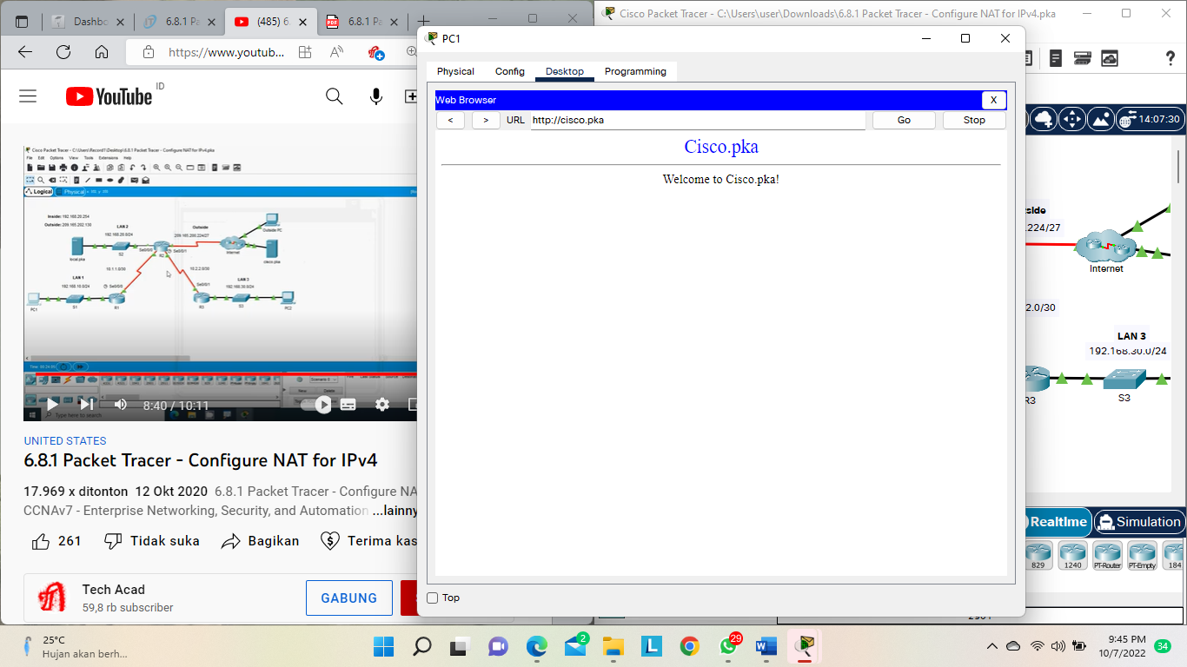

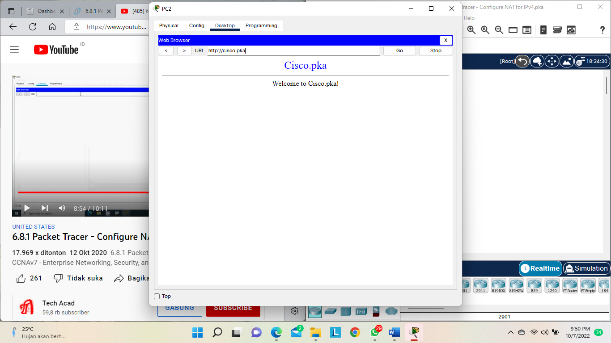

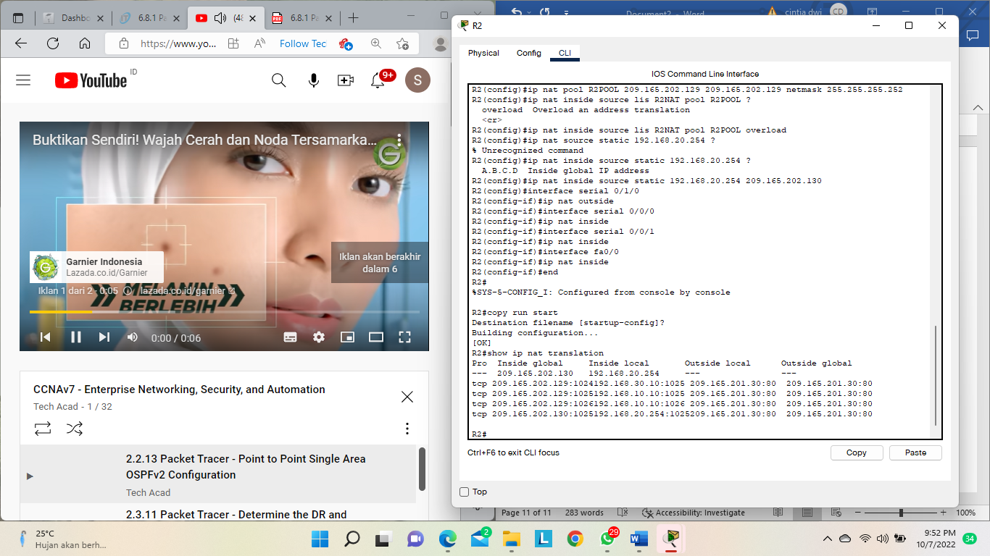

Hasil simulasi :

